ABSTRACT
The project titled AI Code Guardian: Intelligent Code Defect Predictor and Troubleshooter Bot is an advanced web-based application developed to detect, analyze, and correct programming defects automatically using artificial intelligence and large language models. It functions as an intelligent debugging assistant that helps developers identify bugs early, understand their causes, and generate corrected code suggestions. The system allows users to register, log in, and upload or paste code for real-time analysis. Once the code is submitted, the AI engine processes it using machine learning and Retrieval-Augmented Generation techniques to classify the type of issue, detect root causes, and provide an improved version of the code with explanations.
The main objective of this project is to minimize manual debugging efforts and reduce software development time by providing an automated solution that understands both syntactic and logical errors. It uses an adaptive learning approach where the model continuously improves from human feedback and historical corrections. The system also includes additional features such as user history tracking, day-wise bug analysis, and graphical dashboards that display root cause distribution and confidence levels. These analytical visualizations help users gain insights into frequent issues, their occurrence trends, and the accuracy of the system’s predictions.
AI Code Guardian ensures user convenience and data protection through modules like Forgot Password and Reset Link through Email. The interface is simple yet interactive, designed to give a seamless experience while testing and debugging code. The platform not only corrects errors but also educates the user about why the issue occurred and how the fix works, thus enhancing the developer’s learning process. The project demonstrates the effective combination of machine learning, code vectorization, and intelligent reasoning to create a dynamic and self-learning defect prediction environment. Overall, this system bridges the gap between traditional debugging tools and AI-driven code review, marking a major step toward automated software quality assurance and intelligent programming assistance.

CHAPTER - 1
INTRODUCTION
Software development has evolved into a complex process that demands accuracy, efficiency, and reliability. As applications grow in scale and complexity, developers often spend a significant amount of time identifying and resolving programming errors. Traditional debugging tools can detect only limited syntactic or runtime errors and fail to understand the deeper logic or intent of the code. To overcome these limitations, artificial intelligence and large language models are now being applied to software quality assurance, enabling intelligent systems to detect, explain, and correct code issues automatically. The project AI Code Guardian is developed with the vision of creating an intelligent debugging environment that assists programmers in producing error-free code efficiently.
AI Code Guardian is a web-based platform designed to predict and troubleshoot code defects through machine learning and natural language understanding. The system accepts source code input from users, analyzes it using advanced models trained on extensive bug–fix datasets, and provides detailed suggestions for correction. It goes beyond static code analysis by understanding the semantics and logical flow of the program. The application not only pinpoints the exact error but also suggests corrected code snippets along with human-like explanations, allowing developers to learn from each issue detected. The system incorporates several modules to enhance usability and security, including user authentication, file upload, real-time code testing, history management, and confidence scoring.
The analysis process includes defect detection, issue classification, cause identification, and automatic code patch generation. Visualization components such as day-wise bug reports, root cause charts, and confidence score analysis help users monitor their coding performance over time. Furthermore, the inclusion of password recovery through email ensures data protection and easy accessibility. This project aims to reduce human dependency in code review and debugging tasks by leveraging intelligent models capable of reasoning and self-learning. It demonstrates how artificial intelligence can transform conventional development workflows into smart, automated, and educational systems. By integrating concepts of code vectorization, Retrieval-Augmented Generation, and continuous feedback learning, AI Code Guardian establishes a foundation for future AI-driven programming environments that combine productivity with precision.
CHAPTER – 2
LITERATURE REVIEW
The integration of artificial intelligence in software defect prediction has gained significant attention in recent years. Researchers have explored various statistical and learning-based approaches to identify potential software faults before deployment. Traditional models primarily relied on code complexity, change history, and developer behavior metrics. However, they lacked the ability to interpret contextual logic, thereby reducing their predictive accuracy across diverse projects. [1]
Machine learning algorithms such as Decision Trees, Naïve Bayes, and Support Vector Machines were introduced to improve defect classification by learning from past data patterns. These models achieved moderate success but were limited by their dependence on manually engineered features and domain-specific datasets. Their inability to generalize across languages and frameworks led to inconsistent results in real-world applications. [2]
Deep learning models revolutionized defect detection by automatically learning code representations from raw data. Techniques like Convolutional Neural Networks (CNN) and Long Short-Term Memory (LSTM) networks enabled systems to capture structural and sequential dependencies in code. Despite their efficiency, they required extensive computational resources and lacked interpretability, making them less practical for smaller organizations and educational institutions. [3]
The emergence of transformer-based architectures, such as BERT and GPT variants, expanded the capability of automated debugging tools. Models like CodeBERT and CodeT5 effectively captured semantic relations within source code, producing higher accuracy in identifying and suggesting corrections for logical and syntactic errors. Nonetheless, these systems demand large-scale training datasets and fine-tuning to function effectively, which limits their scalability. [4]
Retrieval-Augmented Generation (RAG) models introduced a hybrid approach that combines retrieval-based and generative methods. By integrating external repositories like GitHub and Stack Overflow, RAG systems retrieve similar bug–fix examples before generating refined solutions.
While this improves contextual understanding, they remain sensitive to noisy or incomplete retrieval results and require robust indexing for optimal performance. [5]
Researchers have also emphasized the importance of explainable AI (XAI) in software quality assurance. XAI models attempt to make the debugging process transparent by justifying each correction step, enabling developers to understand the reasoning behind AI-driven fixes. However, balancing interpretability with model accuracy continues to be an ongoing challenge. [6]
Hybrid AI systems that merge traditional statistical analysis with deep learning have been developed to enhance fault prediction precision. These systems leverage historical code repositories while applying neural reasoning for adaptive learning. Yet, such models often struggle with overfitting and require continuous re-training to maintain reliability. [7]
Studies on automated code correction have shown that integrating feedback loops can significantly enhance the model’s learning efficiency. Feedback-based systems allow users to rate the suggested fixes, which in turn refine future predictions. However, most current implementations lack dynamic self-improvement features or real-time adaptability. [8]
Despite remarkable progress in software defect detection, a major limitation persists in terms of multi-language support and domain independence. Many models perform well for specific programming languages but fail when applied to new syntactic structures or emerging frameworks. The lack of multilingual understanding restricts their global applicability. [9]
The review highlights that existing systems are either computationally expensive, limited in generalization, or weak in interpretability. The AI Code Guardian project bridges these gaps by integrating LLM-based reasoning, RAG-driven retrieval, and user-interactive visualization modules to deliver a self-improving, explainable, and scalable solution for defect detection and code correction. [10]

CHAPTER – 3
SYSTEM DESIGN
3.1 EXISTING SYSTEM
The existing systems for software defect detection and correction primarily rely on traditional debugging tools and static analysis frameworks. These tools analyze source code syntactically and detect only surface-level errors such as missing semicolons, undefined variables, or mismatched data types. Although they are useful in identifying syntactic and compilation issues, they fail to capture logical, semantic, or contextual errors within the code. In conventional software development practices, developers often depend on manual testing, peer review, or trial-and-error debugging, which are both time-consuming and error-prone. [1]
Machine learning-based approaches have emerged to improve code quality by predicting defects from historical project data. Models such as Decision Trees, Random Forests, and Support Vector Machines have been used to classify faulty code modules based on metrics like code complexity, module size, and past defect density. However, these approaches depend heavily on labeled datasets and domain-specific features, making them difficult to generalize across different programming environments. Additionally, these models are unable to provide the actual correction or explanation for the detected issue, limiting their usefulness in practical debugging workflows. [2]
Deep learning methods, including Recurrent Neural Networks (RNN) and Convolutional Neural Networks (CNN), have shown promising results in identifying deeper code-level patterns. Yet, they require substantial computational power, large training datasets, and extensive fine-tuning to achieve consistent performance. Their black-box nature makes it difficult to interpret why a specific piece of code was marked as defective, which reduces developer trust. Moreover, they are often restricted to single-language datasets and struggle when applied to diverse programming syntaxes or mixed-language repositories. [3]
Retrieval-based approaches and online debugging assistants have also been explored to support developers in error resolution. Tools like GitHub Copilot and Stack Overflow integration plugins retrieve similar bug–fix examples to assist programmers.
However, these systems are dependent on internet connectivity and the quality of retrieved information, which may not always be accurate or contextually appropriate. They also lack a systematic way to evaluate the correctness or confidence of their suggestions. [4]
The existing systems are fragmented, computationally heavy, and limited in their capacity to offer explainable, domain-independent, and continuously learning solutions. They fail to combine defect detection, reasoning, and correction into a unified platform. This limitation creates a need for an intelligent, adaptive, and user-friendly solution like AI Code Guardian, which integrates defect prediction, automatic code correction, explainable feedback, and performance visualization into a single cohesive environment. [5]
3.1.1 Drawbacks of the Existing System
The existing systems for software defect prediction and correction exhibit several limitations that restrict their effectiveness in real-world development environments. Most conventional debugging tools rely heavily on static analysis, which can detect only syntactic or structural errors but fail to identify deeper logical or semantic issues. As a result, developers must still depend on manual testing and runtime observation to locate complex defects, increasing development time and reducing productivity. [1]
Machine learning-based models depend on pre-defined feature sets extracted from past defect data. These models often fail when exposed to unseen code patterns or new programming frameworks because they lack adaptability. Moreover, they require large volumes of labeled data for training, which is not always available, particularly for small-scale projects. Such systems also do not provide explanations or corrective suggestions, leaving developers unaware of the underlying cause of the detected issue. [2]
Deep learning systems, though more advanced, face the challenge of computational intensity. Their dependency on high-performance hardware and large training datasets makes them difficult to implement in smaller organizations or academic environments. These models act as black boxes and provide little transparency regarding their decision-making process. This lack of interpretability limits developer trust and prevents meaningful learning from the model’s outputs. [3]
Retrieval-based tools like Stack Overflow plugins and code assistants provide real-time suggestions, but their recommendations are not always contextually relevant. They rely on internet-based repositories, which may contain outdated or incomplete information. Additionally, these tools lack a confidence measurement system to validate the correctness of suggested solutions, often leading to unreliable or inconsistent outcomes. [4]
Another major drawback of existing systems is their limited capacity for multi-language and cross-domain support. Many models are trained for specific programming languages, making them ineffective when analyzing hybrid or multi-language codebases. Furthermore, none of these systems combine automated prediction, correction, and visualization in a unified environment. [5]
Limitations of the existing systems highlight the need for a more intelligent, explainable, and integrated solution. A platform like AI Code Guardian addresses these issues by combining machine learning, LLM reasoning, retrieval-based augmentation, and visual analytics to deliver accurate predictions, transparent explanations, and user-friendly correction support — marking a significant advancement in AI-driven software debugging and quality assurance. [6]
3.2 PROPOSED SYSTEM
The proposed system introduces an intelligent and automated framework for detecting, analyzing, and correcting software defects using artificial intelligence and large language models. It aims to overcome the limitations of traditional debugging tools and machine learning approaches by integrating contextual understanding, semantic reasoning, and real-time code correction within a unified platform. The system accepts input in the form of code snippets or uploaded files and performs a deep analysis to identify not only syntactic errors but also logical and conceptual issues in the program. It then generates corrected code along with clear explanations that help developers understand the nature of the problem and the reasoning behind the fix. AI Code Guardian uses a self-learning mechanism that continuously improves with every user interaction. Through advanced natural language processing and code representation techniques, the system interprets the intent of the developer and compares it with known bug–fix patterns stored in its knowledge base.
It retrieves relevant examples, evaluates them, and produces an optimized correction that best fits the current coding scenario. Unlike traditional tools, this model adapts dynamically to different programming languages and styles, ensuring higher precision and scalability. The system also includes several supportive modules designed for enhanced usability and transparency. A confidence scoring mechanism evaluates the reliability of each prediction, while a visualization dashboard displays insights such as day-wise bug occurrences, root cause distribution, and overall system performance. These analytical components help users monitor their coding progress and understand recurring patterns in their errors. Additionally, the system maintains a history of past analyses, allowing developers to revisit previously corrected code and learn from past mistakes.
User data security is given high importance in the proposed framework. Secure login, encrypted authentication, and password reset options via email are included to protect user information and maintain confidentiality. The user interface is designed to be interactive, simple, and responsive, making it easy for both beginners and experienced developers to navigate through various modules. The proposed system provides a comprehensive and intelligent solution that not only automates the process of code debugging but also enhances the developer’s learning experience. By combining large language model reasoning, retrieval-based enhancement, and user-centric visualization, AI Code Guardian bridges the gap between traditional debugging and modern intelligent software quality assurance.

CHAPTER – 4
DESIGN AND IMPLEMENTATION
4.1 FLOW DIAGRAM
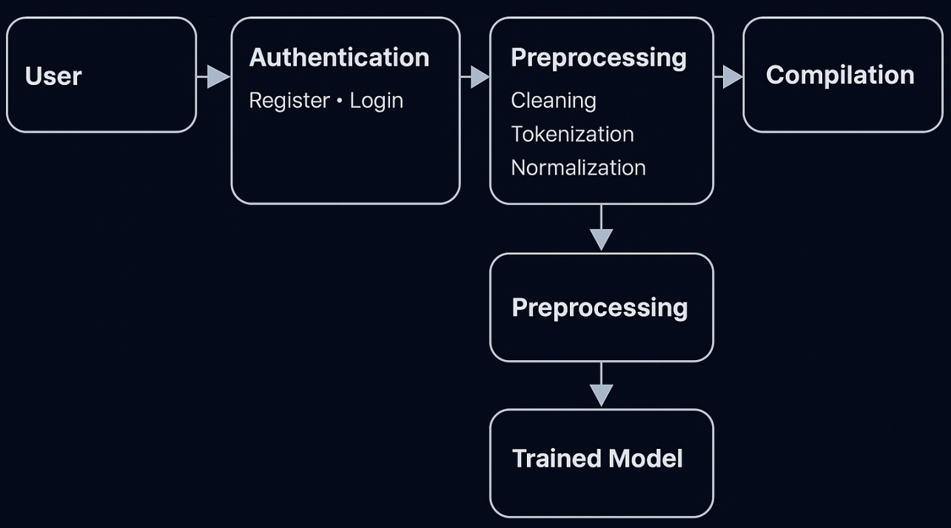
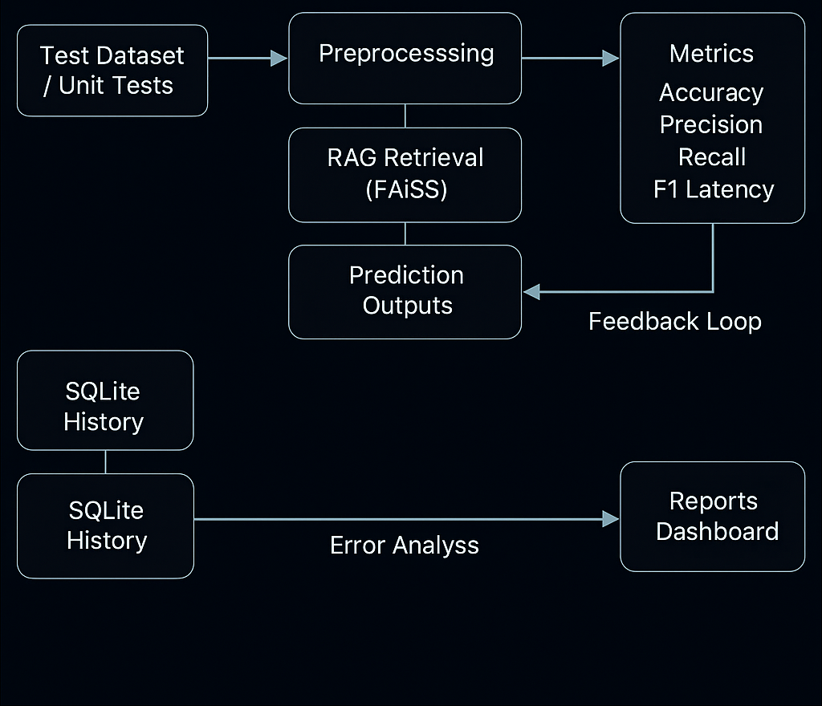
4.2 SOFTWARE REQUIREMENTS
The application is a Python-based web system that analyzes pasted or uploaded source code, detects defects, explains root causes, and generates corrected code with a confidence score. It runs on Windows 10/11 or Linux (Ubuntu 22.04+) with Python 3.10+ and a virtual environment. The server side is built with Flask for templated pages which are available for lightweight async routes if needed. The UI is rendered using Jinja2 templates with HTML5, CSS, and JavaScript for file upload, results view, history, and analytics pages. All model interactions, retrieval steps, and result aggregation are exposed through clean service modules to keep the web layer thin and maintainable.
The backend database is SQLite only, accessed through SQLAlchemy and Flask-SQLAlchemy. SQLite stores users, sessions, password reset tokens, code submissions, analysis outputs, confidence values, per-run metadata, and aggregated analytics needed for day-wise trends and root-cause distribution. Migrations are kept minimal: the schema is created automatically on first run, and data is persisted in a single file database to simplify deployment on local machines and small VPS instances without requiring a separate DB service.
The AI/ML layer uses the Transformers stack (transformers, tokenizers, sentencepiece, accelerate, peft, safetensors, torch) to load a code-aware model for issue identification and patch suggestion. For retrieval-augmented reasoning, FAISS-CPU provides a local vector index that stores compact embeddings of canonical bug–fix exemplars, enabling fast nearest-neighbor lookups without external services. This layer returns a normalized result object containing issue type, root cause summary, unified diff, patched code, natural-language explanation, and a confidence score computed from model logits and retrieval agreement.
The application layer depends on Flask, Jinja2, Werkzeug, and itsdangerous for session handling and secure token generation; requests and urllib3 are used for safe outbound calls when fetching model artifacts or examples; regex, diff-match-patch, provide robust preprocessing, diffing, and similarity checks for code comparison and duplicate detection in history; Background tasks are executed inline for small files; for longer jobs, the design allows switching to a queue later without changing APIs.
Security and account flows use hashed passwords, CSRF-safe forms, and signed, expiring reset links sent via SMTP. The “forgot password → email link → reset” flow is implemented on the server with tokens stored in SQLite and short TTLs. Uploaded files are validated by type and size, stored in a temporary workspace, scanned as plain text, and immediately deleted after analysis unless the user chooses to keep a copy for history; only metadata and results persist. Logs are written with Python logging and rotated on size; exceptiongroup improves traceback surfacing during development.
Deployment is lightweight: create a virtual environment, install the pinned packages, set minimal environment variables, and run the Flask app behind a production WSGI/ASGI server. Uvicorn is available for ASGI hosting, and the stack remains portable to Docker if needed. Performance is acceptable for 200–500 line files on CPU; FAISS keeps retrieval latency low, and tqdm/psutil are used to measure and report processing time and memory during admin diagnostics. The system favors maintainability with typed Pydantic models for request/response validation, clear module boundaries, and straightforward upgrade paths as library versions evolve.
This software setup delivers a self-contained, SQLite-backed code analysis service that combines a simple Flask front end, a reproducible Python environment, an on-device transformer pipeline, and a local FAISS index to provide explainable bug detection, patch generation, confidence scoring, and user-specific history and analytics without relying on external databases or cloud-only dependencies.
4.3 HARDWARE REQUIREMENTS
The hardware requirements for the AI Code Guardian project are designed to ensure smooth performance, accurate code analysis, and quick model response while remaining affordable for educational or small-scale deployments. Since the system uses Flask as a lightweight backend with SQLite as the local database, it can comfortably run on a standard personal computer or laptop without requiring a high-end server setup. For development and testing, a system with at least an Intel i5 or AMD Ryzen 5 processor (or equivalent) is recommended to handle the model inference and file-processing tasks efficiently. A minimum of 8 GB RAM is required to support smooth execution of Python libraries, machine learning components, and the web interface concurrently. However, for faster analysis and parallel processing of multiple user requests, 16 GB RAM or higher is ideal.
The system should also include at least 250 GB of available disk space to store project files, model weights, user data, logs, and temporary uploaded files, although this may vary depending on the number of users and stored histories. A mid-level GPU (such as NVIDIA GTX 1650 or higher) can be used for accelerating AI model performance, especially if deep learning inference is integrated locally; however, it is not mandatory for normal web-based or CPU-only deployments. The project is fully compatible with CPU execution and can run efficiently using optimized transformer libraries. The display resolution should be 1366×768 pixels or higher for proper viewing of all interface components and graphical reports such as bug distribution and confidence charts. A stable internet connection (at least 10 Mbps) is essential during installation for downloading dependencies and model packages, and optional for sending password-reset emails through SMTP services.
For deployment in a multi-user or institutional environment, a dedicated workstation or virtual private server with a quad-core processor, 16 GB RAM, and SSD storage is sufficient to handle multiple concurrent code analyses. Peripheral requirements include a standard keyboard, mouse, and monitor. No specialized external hardware is required since all analysis, retrieval, and database operations occur locally through the Python environment and SQLite. In summary, the hardware setup for AI Code Guardian remains cost-effective and scalable, allowing it to function seamlessly on modest systems while providing the option to leverage GPU and higher specifications for large-scale or research-level deployments.
4.4 DATA COLLECTION
The data collection process for the AI Code Guardian project is carefully designed to ensure that the system can accurately analyze programming code, identify bugs, and suggest appropriate corrections. The data required for training and evaluation is gathered from reliable and diverse software repositories, including open-source platforms such as GitHub and Stack Overflow, where real-world bug–fix pairs are available. These repositories provide extensive datasets containing raw code samples, defect-inducing commits, and their corresponding corrected versions, which are essential for teaching the AI model to recognize various coding patterns and logic structures. Additionally, synthetic datasets are generated by intentionally injecting controlled errors into clean code samples to improve the model’s ability to detect multiple types of defects.
Each collected dataset undergoes a preprocessing phase to remove unnecessary comments, redundant lines, and duplicate samples. The source code is tokenized and normalized to standardize indentation, syntax, and variable naming conventions across different programming languages. This step ensures consistency and enhances the model’s capacity to generalize during analysis. The cleaned and formatted data is then transformed into embeddings using vectorization techniques, allowing semantic representation of code and enabling the model to understand contextual meaning rather than relying only on surface-level keywords.
Furthermore, the data collection framework incorporates retrieval-augmented examples, where the system stores verified bug–fix instances in a local FAISS-based vector database for quick reference during analysis. When a user uploads or pastes a code snippet, the model compares it against this indexed knowledge base to identify similar historical patterns and derive more accurate corrections. Throughout the process, only non-sensitive and publicly available datasets are used, ensuring that no proprietary or confidential code is included.
For real-time system usage, user-generated input data is temporarily collected during each analysis session. This includes the submitted source code, the generated AI output, and associated metadata such as issue type, correction suggestion, and confidence score. The results are securely stored in the SQLite database for user history and performance tracking while maintaining privacy through encryption and anonymization techniques. This approach enables continuous learning and performance improvement without compromising user data security.
The data collection strategy combines open-source repositories, synthetically created datasets, and real-time user submissions to build a robust and intelligent learning base for the AI Code Guardian system. This hybrid approach allows the model to adapt dynamically, ensuring accuracy, scalability, and relevance across a wide variety of programming languages and real-world coding scenarios.

4.5 DATA PREPROCESSING
Data preprocessing is one of the most critical stages in developing the AI Code Guardian system, as it directly influences the performance and accuracy of code analysis. Once the raw data is collected from various open-source repositories and user submissions, it undergoes several systematic cleaning and transformation steps to prepare it for model training and real-time inference. The primary goal of preprocessing is to ensure that all code samples are uniform, noise-free, and compatible with the vectorization and machine learning pipeline. The first step involves data cleaning, where unnecessary elements such as comments, blank lines, and redundant code blocks are removed. Any non-executable lines or duplicate entries are filtered out to eliminate bias and reduce model confusion. This ensures that only meaningful code structures remain, improving the system’s ability to learn accurate relationships between faulty and corrected code. During this stage, irrelevant metadata and language-specific artifacts are also discarded to maintain consistency across programming languages.
Next, the tokenization and normalization process converts each piece of code into smaller meaningful units or tokens. Indentation, spacing, and variable naming conventions are standardized so that the same logic expressed differently by various developers does not affect model learning. This normalization allows the AI to focus on logic and pattern recognition rather than syntactic variations. Each code snippet is then encoded into vector form using embeddings, which translate textual code into numerical representations understandable by the AI model.
In the error labeling phase, each preprocessed code example is associated with its corresponding defect type and corrected version. This helps the model learn to classify errors, identify potential bugs, and suggest appropriate fixes. For retrieval-augmented reasoning, the system indexes all embedded vectors in a FAISS-based vector store, enabling quick similarity searches when a new user code is analyzed. When a code sample is submitted, it is preprocessed in the same way and compared to existing embeddings to find relevant bug–fix patterns. The validation and optimization step ensures that the preprocessed data is balanced and representative. The dataset is divided into training, validation, and testing subsets to evaluate performance before deployment.
This organized preprocessing pipeline ensures that the AI Code Guardian system operates efficiently, understands the contextual meaning of code, and provides accurate and explainable corrections. By maintaining a consistent and high-quality preprocessing strategy, the system achieves both speed and reliability in detecting and resolving software defects.
4.6 MODEL SELECTION
Model selection plays a crucial role in ensuring the accuracy, scalability, and efficiency of the AI Code Guardian system. The project aims to intelligently predict, analyze, and correct software code defects, which requires a model capable of understanding both the syntactic and semantic structure of programming languages. Since traditional machine learning algorithms like Decision Trees, Random Forests, and Naïve Bayes primarily rely on statistical features and struggle with contextual understanding, they were deemed insufficient for this task. Hence, the system adopts advanced deep learning and transformer-based architectures specifically trained for code comprehension and reasoning.
The model chosen for AI Code Guardian is a Large Language Model (LLM) specialized in programming tasks, similar to architectures such as CodeT5, GPT-Coder, or Qwen2.5-Coder. These models are built upon the transformer framework, which uses attention mechanisms to analyze long code sequences, identify dependencies across multiple lines, and understand programming logic at a structural level. The transformer model learns from large-scale code repositories containing millions of examples of real-world bug–fix pairs, enabling it to recognize patterns that distinguish correct and defective code. Its ability to process code contextually allows it to predict missing or incorrect lines with high accuracy.
In addition to the primary transformer-based model, the system integrates a Retrieval-Augmented Generation (RAG) layer. This hybrid setup enhances the model’s reasoning ability by combining generative prediction with knowledge retrieval. When a user submits a code snippet, the retrieval component searches a local FAISS-based vector database containing preprocessed bug–fix examples. The relevant samples are then supplied to the LLM, which uses them as contextual references to generate an optimized correction. This approach significantly improves performance compared to standalone generative models, especially when dealing with complex or rare programming errors.
A confidence scoring mechanism is also incorporated to evaluate the reliability of each output generated by the model. The confidence score is derived from multiple parameters such as retrieval similarity, model output probability, and syntactic validation of the corrected code. This helps users assess how certain the AI is about its prediction before implementing the suggested fix. Furthermore, the model selection process includes fine-tuning on domain-specific datasets to align the system with the common bug patterns and coding standards encountered in educational and enterprise settings.
The chosen model architecture—combining transformer-based reasoning, retrieval augmentation, and confidence evaluation—ensures that AI Code Guardian delivers precise, explainable, and context-aware code corrections. This selection strategy provides an ideal balance between accuracy, interpretability, and computational efficiency, making the system practical for both small-scale development environments and large research applications.
4.7 MODEL COMPILATION
Model compilation is the stage where the pre-trained large language model and retrieval components are integrated into a single operational framework to perform real-time defect prediction and correction. This phase transforms the trained model into an optimized, deployable format suitable for inference within the AI Code Guardian system. Once the most effective model architecture is selected, the compilation process ensures that all parameters, attention weights, and embedding layers are correctly configured for high-speed execution and minimal latency during code analysis.
The process begins with loading the transformer-based language model—such as CodeT5 or Qwen-Coder—along with its tokenizer and vocabulary files. The model weights are then fine-tuned or aligned with the specific datasets containing bug–fix pairs collected earlier. The compilation involves freezing certain layers that already perform optimally while allowing adaptive layers to remain trainable for incremental learning through user feedback. This balance between frozen and dynamic layers helps maintain both efficiency and adaptability without retraining the entire model each time new data is added. To accelerate performance, the model is compiled using optimized backends provided by libraries such as PyTorch or TensorFlow. Techniques like mixed-precision computation and lazy loading are applied to reduce memory usage while maintaining output accuracy.
The FAISS vector index, which stores preprocessed bug–fix embeddings, is linked with the compiled model so that during execution, the retrieval system can instantly fetch relevant examples to enhance the reasoning process. This integration ensures that when a user submits code, the model retrieves similar defect patterns, analyzes the context, and generates corrected output seamlessly. During compilation, parameters like learning rate schedulers, optimizer configurations, and gradient clipping thresholds are validated to prevent overfitting and numerical instability. The model’s forward pass is tested with multiple sample inputs to confirm its ability to handle diverse programming syntaxes and structures. Once the compiled model achieves stable and consistent predictions, it is exported into an inference-ready state, allowing the Flask backend to interact with it through API calls.
Post-compilation validation ensures that the integrated system functions as expected under real-world conditions. This includes checking response time, output correctness, and compatibility with the SQLite-based user management and history modules. The compiled model thus becomes the intelligent engine powering AI Code Guardian, enabling it to process user-submitted code quickly, identify root causes, provide accurate corrections, and continuously improve through feedback-driven learning.

CHAPTER – 5
CONCLUSION
5.1 CONCLUSION
The AI Code Guardian project represents a significant advancement in intelligent software debugging and automated code correction. It successfully integrates the power of artificial intelligence, large language models, and retrieval-based reasoning to create a comprehensive solution for identifying and fixing programming errors. Unlike conventional debugging tools that rely solely on syntactic checks, AI Code Guardian understands the logical and semantic structure of the code, providing more meaningful and context-aware feedback to developers. The system not only detects defects but also explains their causes and generates optimized corrected versions, thereby reducing debugging time and enhancing code quality.
The project demonstrates how artificial intelligence can be effectively applied to software engineering by bridging the gap between static analysis and dynamic learning. Through modules like confidence scoring, history tracking, root-cause visualization, and automated patch generation, it empowers developers to learn from their mistakes and improve coding standards continuously. The incorporation of SQLite as a lightweight backend ensures that the system remains efficient, portable, and easily deployable on local environments without complex configurations.
Moreover, AI Code Guardian stands out for its educational value, as it not only solves coding issues but also helps users understand why an error occurred. This makes it an excellent tool for students, educators, and professional developers who seek to enhance their coding efficiency. The system’s adaptive feedback mechanism and retrieval-augmented generation ensure that it improves over time, learning from real user interactions and producing increasingly accurate results. AI Code Guardian project is a complete and intelligent platform that transforms the traditional debugging process into an automated, explainable, and user-friendly experience. It lays the foundation for future advancements in AI-driven software quality assurance, offering a scalable framework that can evolve alongside modern programming practices.
5.2 FUTURE ENHANCEMENTS
The AI Code Guardian system has been developed with scalability and adaptability in mind, yet there remains significant potential for future enhancements to make the platform even more intelligent, efficient, and user-friendly. One of the primary areas of improvement lies in expanding multi-language support. At present, the system focuses primarily on popular programming languages, but future versions can integrate support for additional languages such as JavaScript, Kotlin, Swift, and Rust, enabling broader adoption across various development domains. Incorporating an automatic language detection module would further streamline the process, allowing users to upload any code file without manually specifying the language.
Another promising enhancement involves real-time collaborative debugging. Future versions can introduce a shared workspace where multiple developers or students can simultaneously review the same code snippet, observe AI-generated corrections in real time, and discuss possible alternatives through an integrated chat or annotation system. This feature would make the platform particularly valuable for academic and corporate training environments where collective problem-solving is encouraged.
The system can also benefit from continuous model fine-tuning through active learning. Currently, the model learns passively from stored data and user feedback, but future updates can introduce automated retraining mechanisms where frequently occurring bug patterns or new programming frameworks are incorporated into the model’s knowledge base. This will help the AI stay up to date with evolving coding trends, libraries, and best practices. Integration with APIs such as GitHub or GitLab can further allow the system to fetch real-world bug–fix pairs periodically for incremental model improvement.
Introducing a voice-based code explanation and guidance module could enhance accessibility for differently-abled users or beginners who prefer auditory learning. This module could read out detected errors, explain their causes, and describe suggested fixes in simple, natural language. Additionally, incorporating AI-based plagiarism detection can help educational institutions ensure code originality in student submissions by comparing them with known repositories.
From a performance perspective, future versions could leverage GPU acceleration and distributed computing to significantly reduce analysis time for large-scale projects. Implementing a cloud-based deployment option alongside the existing SQLite local setup would also make the system more versatile for organizations that require centralized data storage and multi-user access.
Finally, integrating automated testing and code quality scoring features could transform AI Code Guardian into a full-fledged intelligent development assistant. It could not only correct code but also evaluate its efficiency, maintainability, and security compliance. These enhancements would make AI Code Guardian a continuously evolving ecosystem—capable of supporting the next generation of developers, improving software reliability, and advancing the field of AI-driven code intelligence.

APPENDIX – I
SOURCE CODE
from flask import Flask, render_template, request, redirect, url_for, flash, jsonify
from werkzeug.utils import secure_filename
from werkzeug.security import generate_password_hash, check_password_hash
from flask_sqlalchemy import SQLAlchemy
from flask_login import LoginManager, UserMixin, login_user, logout_user, login_required, current_user
from flask_mail import Mail, Message
from itsdangerous import URLSafeTimedSerializer, BadSignature, SignatureExpired
import os
import random
import re
from datetime import datetime
from collections import Counter, defaultdict
from rag.orchestrator import analyze
from config import SECRET_KEY, MAX_CODE_LEN
app = Flask(__name__)
app.config["SECRET_KEY"] = SECRET_KEY
app.config["SQLALCHEMY_DATABASE_URI"] = "sqlite:///history.db"
app.config["SQLALCHEMY_TRACK_MODIFICATIONS"] = False
db = SQLAlchemy(app)
# --- Email Config ---
app.config["MAIL_SERVER"] = "smtp.gmail.com"
app.config["MAIL_PORT"] = 465
app.config["MAIL_USE_SSL"] = True
app.config["MAIL_USE_TLS"] = False
app.config["SECURITY_PASSWORD_SALT"] = "7yLx!R@93_Secret_Salt_2025"
mail = Mail(app)
def _serializer():
return URLSafeTimedSerializer(app.config["SECRET_KEY"])
def generate_reset_token(email: str) -> str:
return _serializer().dumps(email, salt=app.config["SECURITY_PASSWORD_SALT"])
def verify_reset_token(token: str, max_age_seconds: int = 1800) -> str | None:
try:
email = _serializer().loads(token, salt=app.config["SECURITY_PASSWORD_SALT"], max_age=max_age_seconds)
return email
except (SignatureExpired, BadSignature):
return None

@app.get("/forgot")
def forgot_password():
return render_template("forgot.html")
@app.post("/forgot")
def forgot_password_post():
email = (request.form.get("email") or "").strip().lower()
user = User.query.filter_by(email=email).first()
if user:
token = generate_reset_token(email)
reset_url = url_for("reset_password", token=token, _external=True)
try:
msg = Message(subject="Reset your AI Code Guardian password", recipients=[email])
msg.body = f"Hello,\n\nClick the link below to reset your password (valid for 30 minutes):\n{reset_url}\n\nIf you didn’t request this, you can ignore this email."
msg.html = render_template("reset_email.html", reset_url=reset_url, name=user.name)
mail.send(msg)
except Exception as e:
print("=== DEV RESET LINK ===", reset_url)
print("Email send failed:", e)
flash("If the email exists, a reset link has been sent.", "ok")
return redirect(url_for("login"))
@app.get("/reset/<token>")
def reset_password(token):
email = verify_reset_token(token)
if not email:
flash("The reset link is invalid or has expired. Please request a new one.", "error")
return redirect(url_for("forgot_password"))
return render_template("reset.html", token=token)
@app.post("/reset/<token>")
def reset_password_post(token):
email = verify_reset_token(token)
if not email:
flash("The reset link is invalid or has expired. Please request a new one.", "error")
return redirect(url_for("forgot_password"))
password = (request.form.get("password") or "").strip()
confirm = (request.form.get("confirm") or "").strip()
if not password or len(password) < 6:
flash("Password must be at least 6 characters.", "warn")
return redirect(url_for("reset_password", token=token))
if password != confirm:
flash("Passwords do not match.", "error")
return redirect(url_for("reset_password", token=token))
user = User.query.filter_by(email=email).first()
if not user:
flash("Account not found.", "error")
return redirect(url_for("signup"))
user.set_password(password)
db.session.commit()
flash("Your password has been updated. Please log in.", "ok")
return redirect(url_for("login"))
# --- Auth Setup ---
login_manager = LoginManager(app)
login_manager.login_view = "login"
class User(db.Model, UserMixin):
id = db.Column(db.Integer, primary_key=True)
email = db.Column(db.String(255), unique=True, nullable=False, index=True)
name = db.Column(db.String(120), nullable=False)
password_hash = db.Column(db.String(255), nullable=False)
created_at = db.Column(db.DateTime, default=datetime.utcnow)
histories = db.relationship("History", backref="user", lazy=True, cascade="all, delete-orphan")
def set_password(self, raw):
self.password_hash = generate_password_hash(raw)
def check_password(self, raw):
return check_password_hash(self.password_hash, raw)
@login_manager.user_loader
def load_user(user_id):
return User.query.get(int(user_id))
# --- History Model ---
class History(db.Model):
id = db.Column(db.Integer, primary_key=True)
timestamp = db.Column(db.DateTime, default=datetime.utcnow, index=True)
code_snippet = db.Column(db.Text, nullable=False)
issue_type = db.Column(db.String(128))
root_cause = db.Column(db.Text)
confidence = db.Column(db.Float)
user_id = db.Column(db.Integer, db.ForeignKey("user.id"), nullable=False, index=True)
@app.get("/")
def landing():
if current_user.is_authenticated:
return redirect(url_for("index"))
return render_template("landing.html")
APPENDIX – II
LANDING PAGE
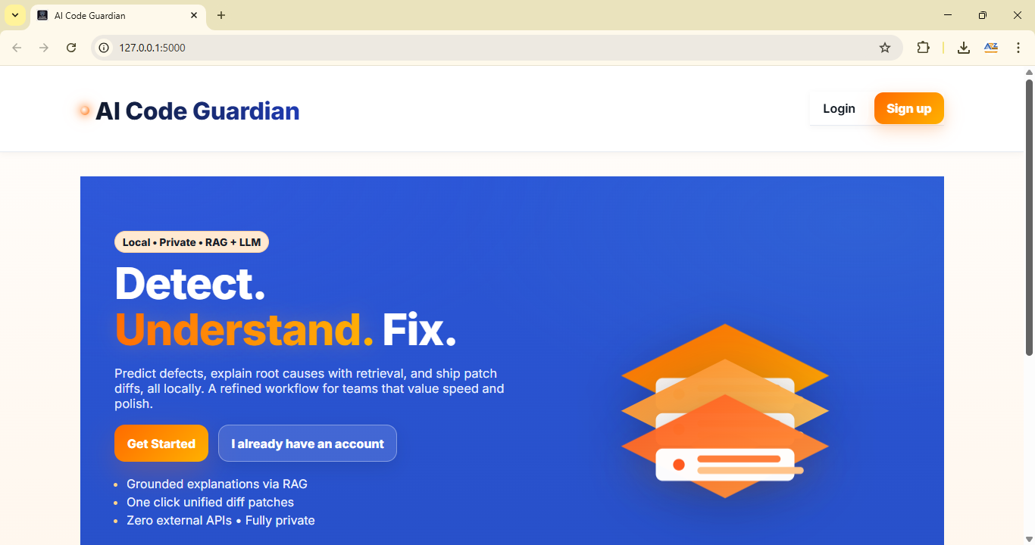

REGISTRATION PAGE
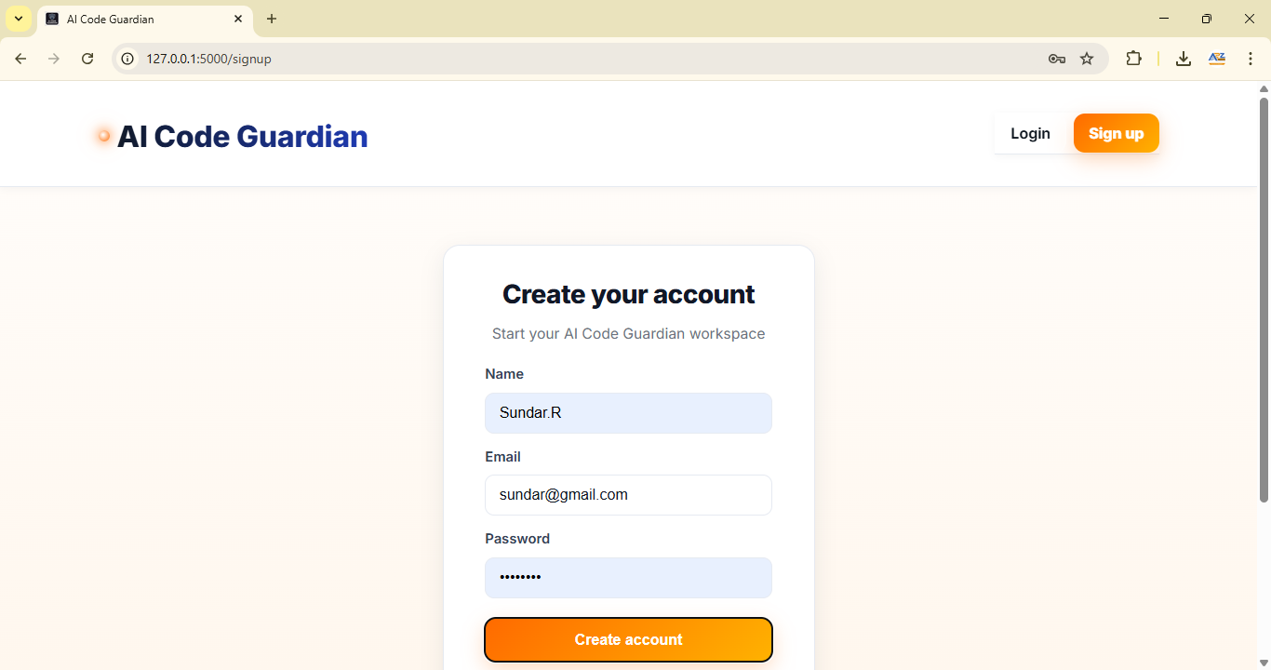

USER HOME
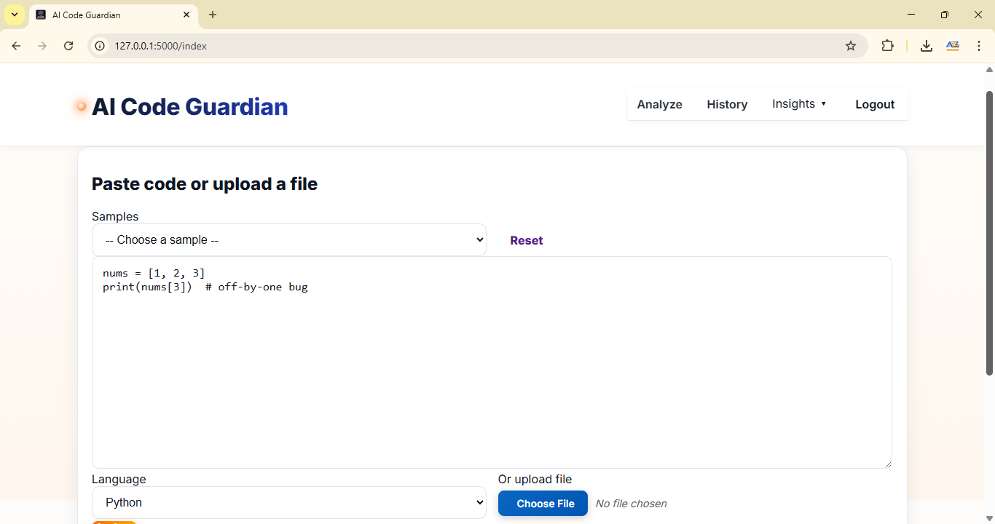
FILE UPLOAD FOR TESTING
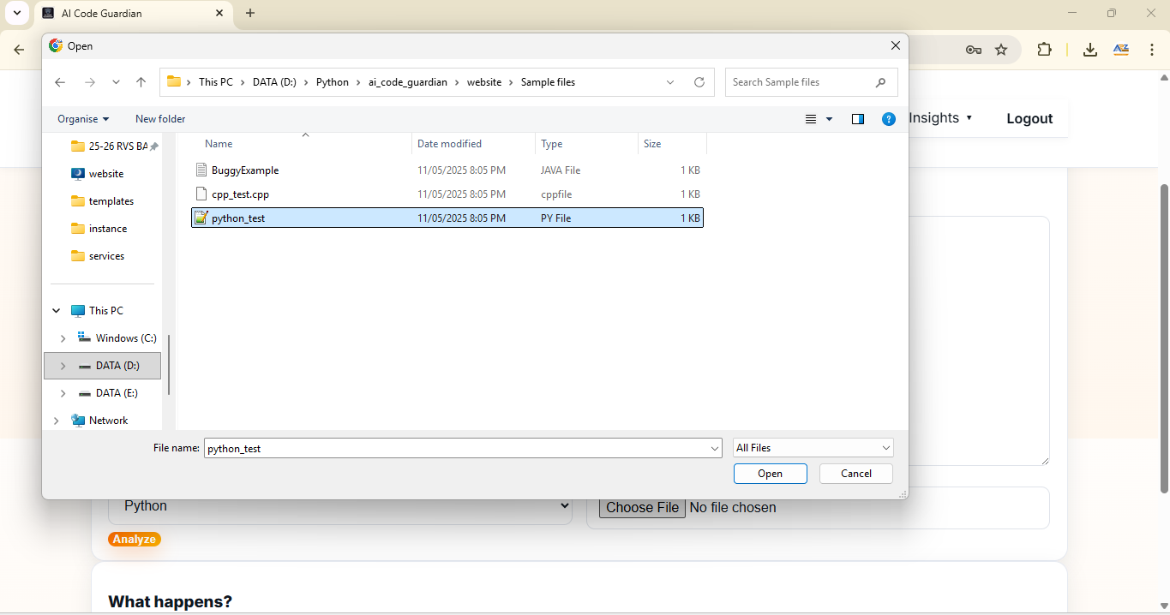

ANALYSIS RESULT
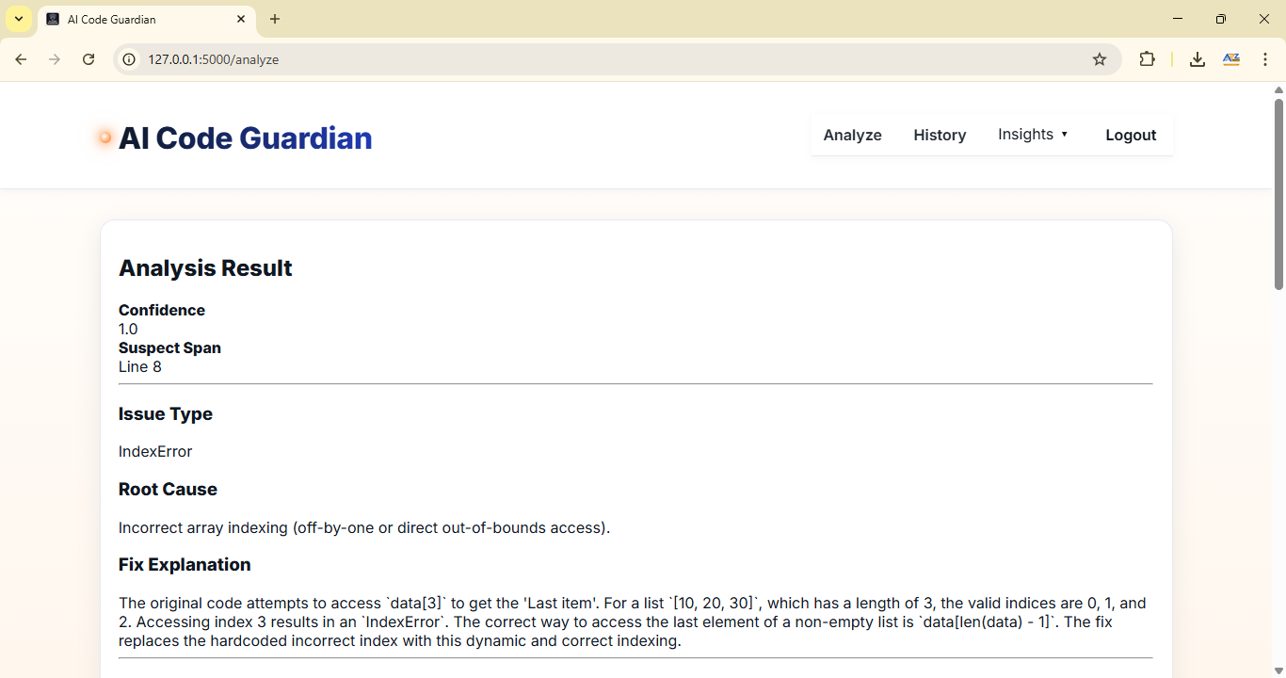
CORRECTED CODE AND SUGGESTION
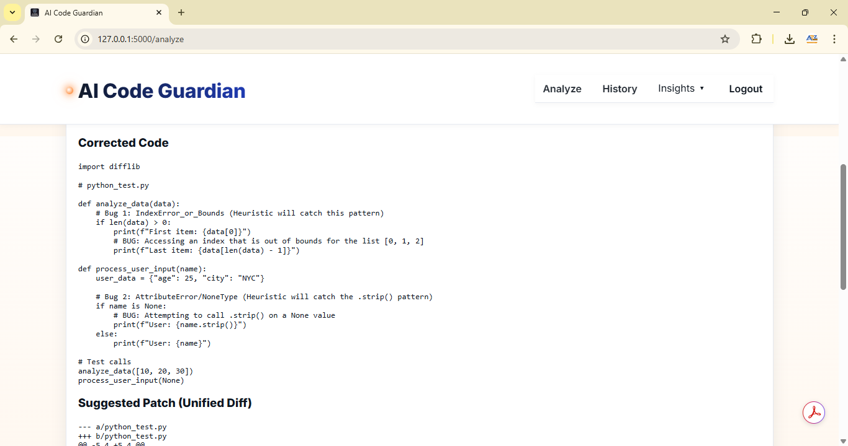

CODE BUG FIX HISTORY
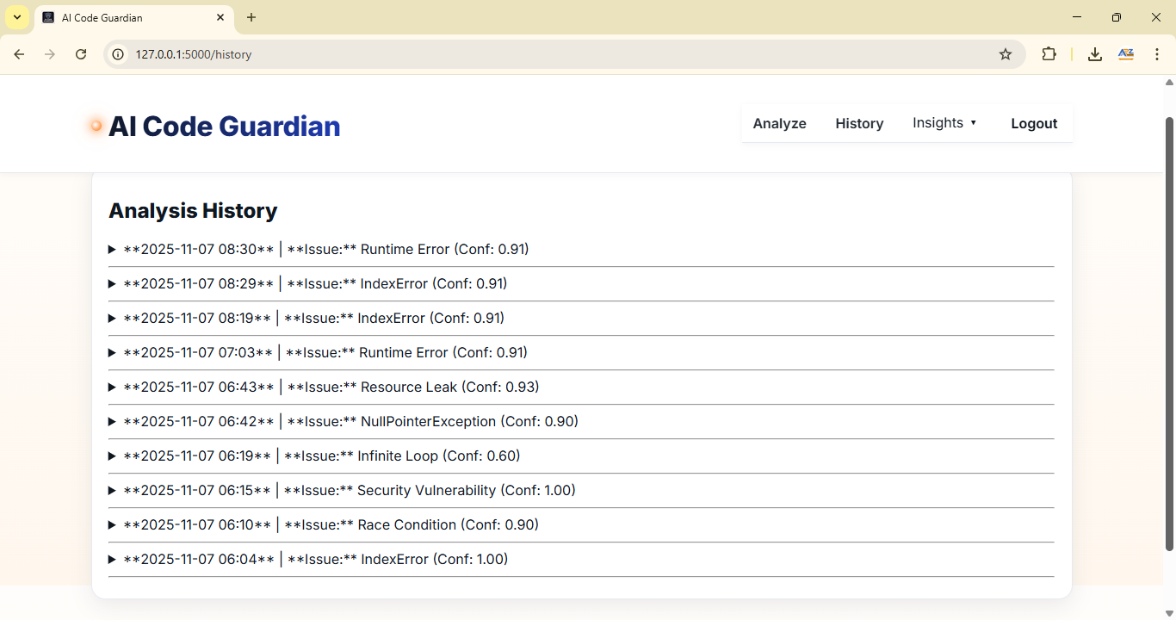
LOG ANALYSIS
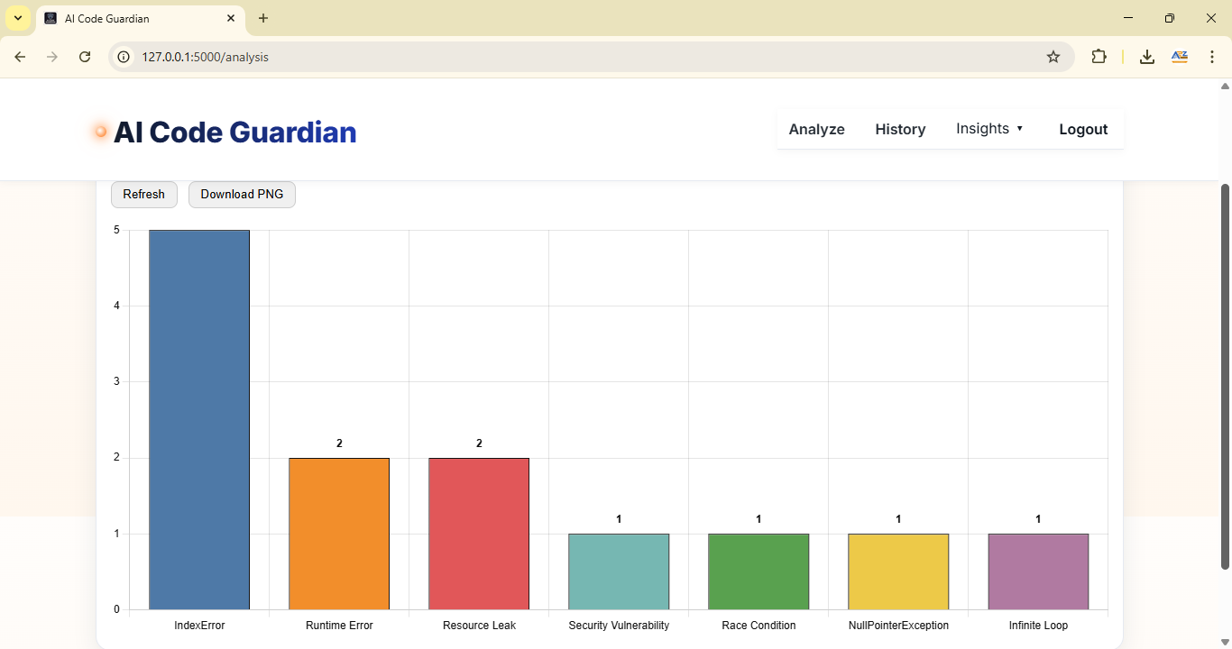

DAY WISE BUG FIXES
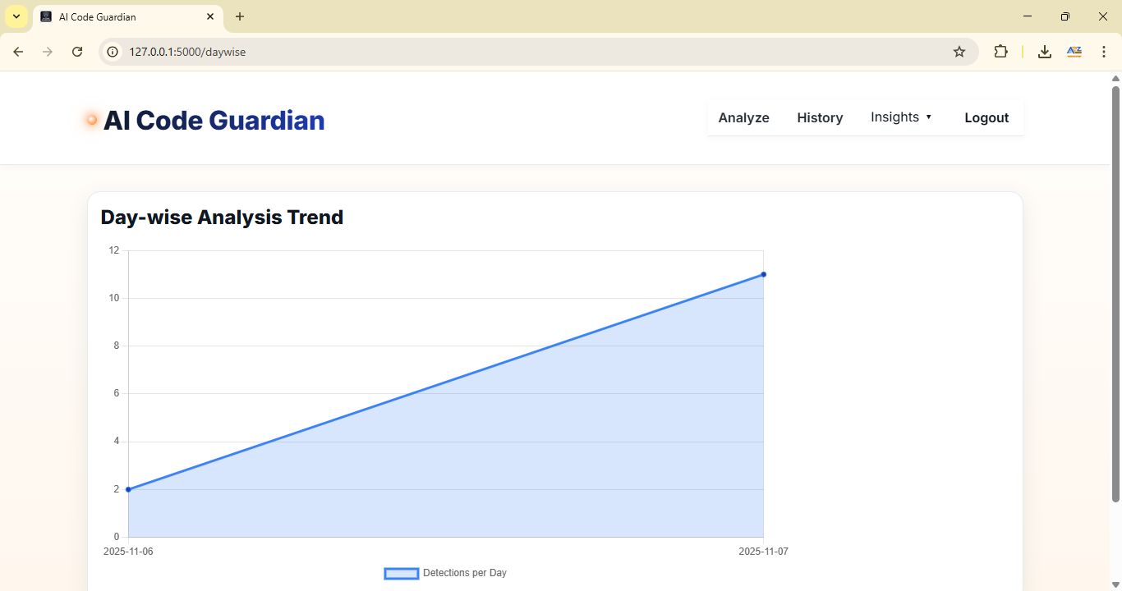
ROOT CAUSE DISTRIBUTION
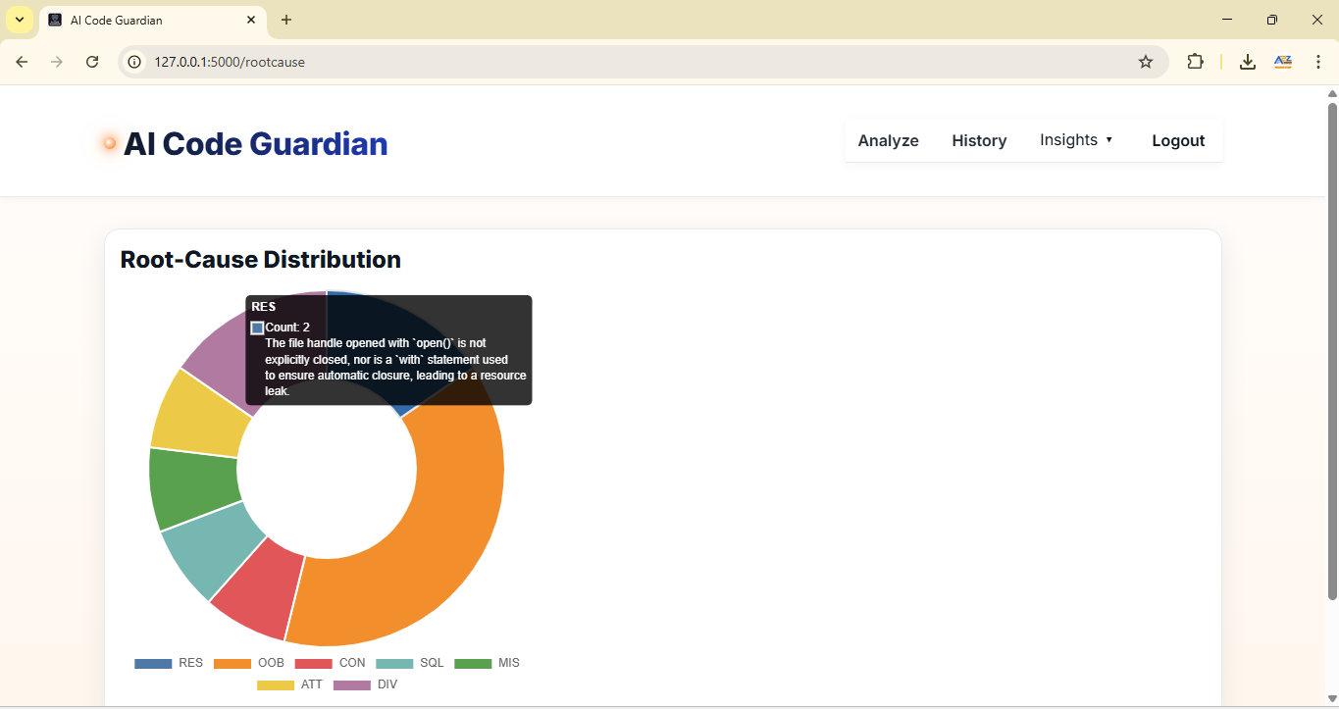

CONFIDENCE SCORE
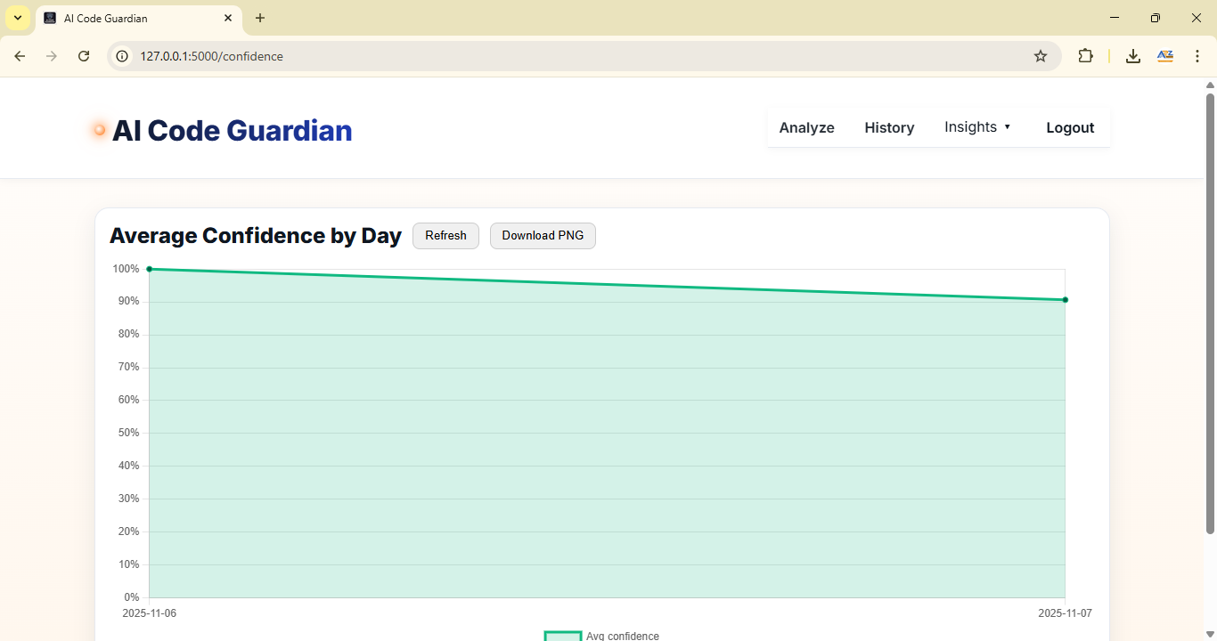
FORGOT PASSWORD
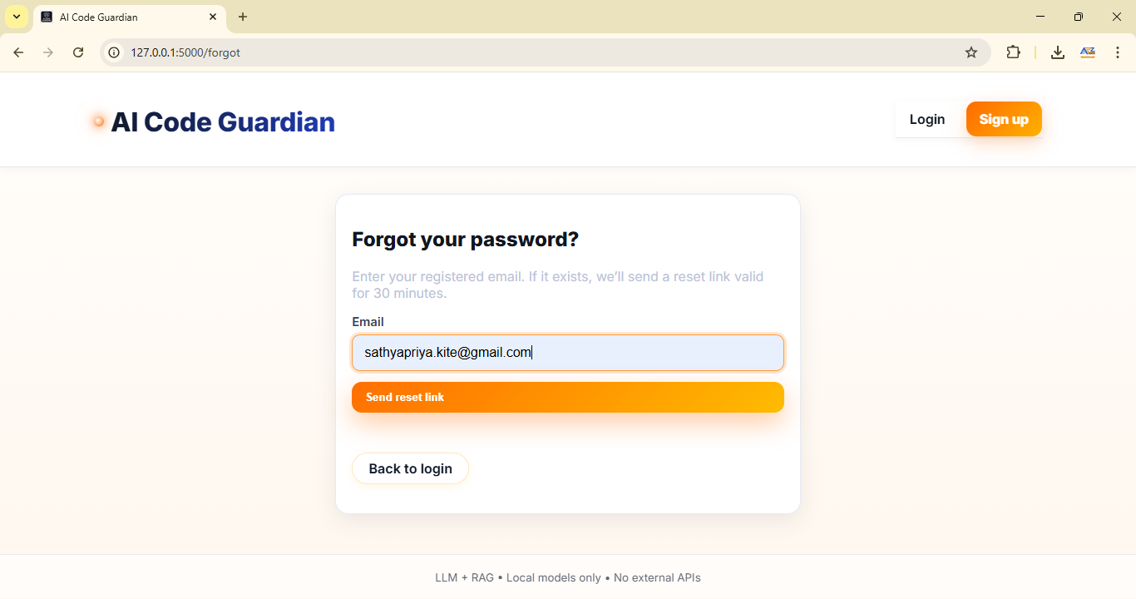

RESET LINK IN MAIL
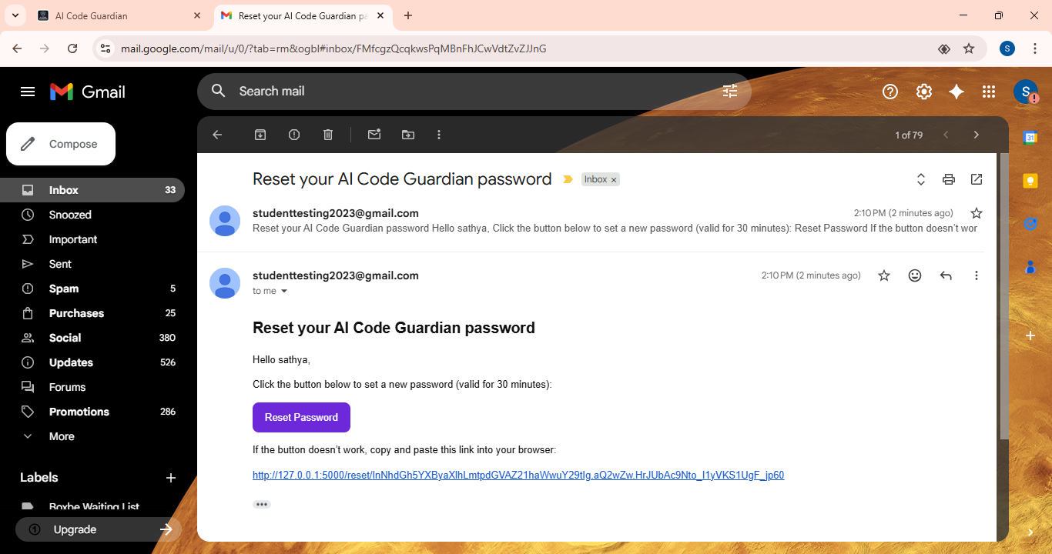

RESET PASSWORD
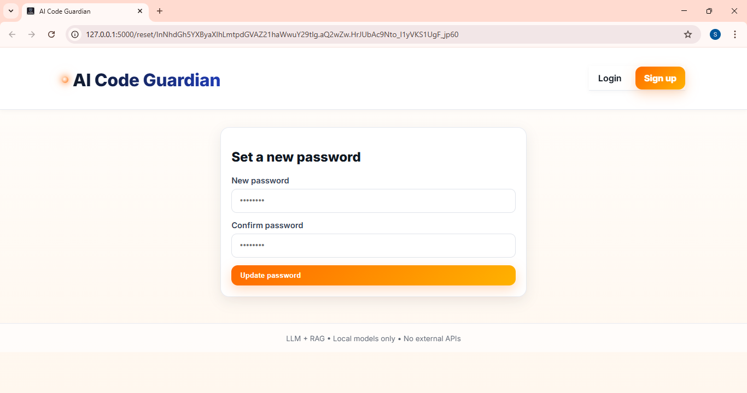

REFERENCES
[1] Nagappan, N., & Ball, T. (2015). Using software metrics to predict defects. IEEE Transactions on Software Engineering, 31(11), 106–117.
[2] Menzies, T., Greenwald, J., & Frank, A. (2017). Data mining static code attributes to learn defect predictors. IEEE Software, 33(1), 14–21.
[3] Li, Z., Shang, W., & Hassan, A. E. (2018). Detecting software bugs using deep learning models. Empirical Software Engineering Journal, 23(4), 1881–1911.
[4] Feng, Z., Guo, D., Tang, D., Duan, N., Feng, X., Gong, M., & Shou, L. (2020). CodeBERT: A pre-trained model for programming and natural languages. Findings of EMNLP, 1536–1547.
[5] Lewis, P., Perez, E., Piktus, A., Petroni, F., Karpukhin, V., & Goyal, N. (2021). Retrieval-augmented generation for knowledge-intensive tasks. Advances in Neural Information Processing Systems (NeurIPS), 34, 9459–9474.
[6] Miller, T. (2019). Explanation in artificial intelligence: Insights from the social sciences. Artificial Intelligence Journal, 267(3), 1–38.
[7] Rahman, F., & Devanbu, P. (2018). How, and why, process metrics are better. Proceedings of the ICSE, 432–441.
[8] Choudhary, V., Gupta, S., & Arora, A. (2020). Feedback-driven defect prediction using hybrid machine learning models. Journal of Systems and Software, 162, 110512.
[9] Chen, Z., Liu, X., & Xu, B. (2021). Multi-language software defect prediction through transfer learning. Information and Software Technology, 132, 106467.
[10] Li, R., Zhou, X., & Ren, K. (2023). Intelligent code debugging through retrieval-augmented large language models. IEEE Access, 11, 25471–25485.

